FINAL YEAR PROJECT 2025

Student Career Experience Simulator

SOFTWARE ENGINEERING (SWE)

Computer and Information Department (CID)

GERMAN – MALAYSIAN INSTITUTE (GMI)

STUDENT NAME : NURUL RABIATUL ADAWIYAH BT MUHAMAD ILHAM
STUDENT ID : SWE24070909
SEMESTER : 4
TRADE : DSWE JULY 2024
SUPERVISOR : MS. ATIQAH
Table of Contents
Contents
1.0 INTRODUCTION 3
2.0 PROBLEM STATEMENT 4
3.0 OBJECTIVES 5
4.0 PROJECT SPECIFICATIONS 6
4.1 Types of System 6
4.2 Targeted Users 6
4.3 Project Features 6
4.4 Project Methodology 6
5.0 SYSTEM DESIGN 7
5.1 Flowchart 7
6.0 TECHNICAL CONTRIBUTION 8
6.1 Technical Knowledge 8
6.2 Relationship of the Project to Software Engineering………………………………………….8

INTRODUCTION

Choosing a career is an important decision for students, but many students select their future profession without fully understanding the actual job scope involved. Most students rely on textbooks, lectures, career talks, and written examinations to learn about different careers. However, these methods mainly focus on theory and do not show how the job is performed in real working situations.

In real life, most jobs require practical skills such as decision-making, time management, problem-solving, and handling responsibility. Students usually do not experience these aspects until they enter higher education, internships, or the working environment. As a result, some students feel unprepared or realize that the chosen career does not match their interests or abilities.

This project proposes the development of a Student Career Experience Simulator System, which allows students to experience real job scopes through interactive simulations. Instead of learning only from books or exams, students can perform job-related tasks in a simulated environment. The system focuses on helping students understand what a job actually involves before making a career decision.

By providing hands-on experience in a safe and controlled environment, this system supports experiential learning and helps students make more informed career choices. This project also contributes to improving career readiness and reducing skill mismatch in the future workforce.

PROBLEM STATEMENT

Many students choose their career paths without a clear understanding of the actual job responsibilities and daily tasks involved in different professions. Current career guidance methods mainly depend on academic results, theoretical learning, and paper-based assessments. Although these methods provide basic knowledge, they do not expose students to real job workflows, workplace pressure, or decision-making situations.

Because of this limitation, students may enter a course or profession without knowing what the job truly requires. This can lead to loss of interest, low motivation, stress during internships, and dissatisfaction with the chosen career. In some cases, students only realize that a career is not suitable for them after spending several years studying.

There is currently a lack of systems that allow students to experience real job scopes in a practical and interactive way before committing to a career path. Therefore, there is a need for a system that enables students to perform job-related tasks and experience realistic working situations in a simulated environment.

OBJECTIVES

- To simulate real job workflows and responsibilities from selected professions

- To allow students to perform job-related tasks in a simulated environment

- To demonstrate realistic outcomes based on students’ decisions

- To evaluate students’ performance based on how they complete job tasks

- To help students understand whether a particular career suits their interests and abilities

PROJECT SPECIFICATIONS

Types of System
The proposed system is a web-based interactive simulation system. It allows users to access the system using a web browser without the need for special hardware. The system emphasizes experiential learning by allowing students to perform job-related tasks in a simulated environment.

  - Targeted Users
    - Students – To experience real job scopes and understand career responsibilities
    - Career Counselors / Educators – To guide students in career exploration
    - System Administrator – To manage users, careers, and simulation scenarios

Project Features
    - User Registration and Login
    - Career Selection Module
    - Job Scope Simulation Module
    - Scenario-Based Task Execution
    - Decision and Consequence Engine
    - Performance Evaluation System
    - Career Suitability Feedback
    - Admin Management Module
    - Progress Tracking and Reports

Project Methodology

This project follows the Waterfall development methodology, as it provides a clear and structured approach suitable for academic projects.

The development phases include:

Requirement Analysis – Identify system requirements and user needs

System Design – Design system architecture and UML diagrams

Implementation – Develop system modules and features

Testing – Perform functional and usability testing

Deployment – Prepare the system for user access

SYSTEM DESIGN

Flowchart

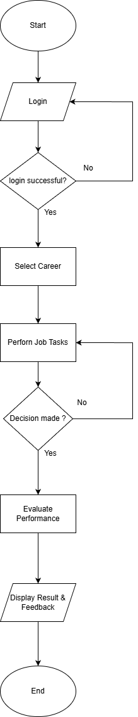

TECHNICAL CONTRIBUTION

Technical Knowledge

This project demonstrates technical knowledge in designing and developing a Student Career Experience Simulator System. The system is designed using a structured approach based on software engineering principles.

The project involves analyzing system requirements to identify user roles, system functions, and simulation workflows. A rule-based logic approach is used to control job scope simulations, where student decisions determine the outcome of each scenario. This logic ensures that the simulation follows realistic job workflows.

The system also uses a database to store user information, selected careers, simulation scenarios, decisions made by students, and performance results. This allows the system to track progress and generate feedback reports.

In addition, system design techniques such as Use Case Diagrams, Activity Diagrams, and Flowcharts are applied to model system behavior before implementation. These diagrams help ensure that the system structure is clear, logical, and easy to maintain.

  - Relationship of the Project to Software Engineering

This project is strongly related to Software Engineering as it follows the Software Development Life Cycle (SDLC) from the initial planning stage until testing and evaluation.
The project includes:

- Requirement analysis to understand user needs
- System design using UML diagrams
- Implementation of system modules
- Testing to ensure system functionality and reliability

